A Machine Learning Model for Stock Market
Prediction

Authors-T. Akhila , S.Sangeetha
Designation-“Intern at inventereon technologies”
Email-id’s-akhila1998akhila@gmail.com,ss030498@gmail.com
Phone_number:-8553189360,9113518004

Abstract-Stock market prediction is the act of trying to
determine the future value of a company stock or other
financial instrument traded on a financial exchange. The successful prediction of a stock's future price will
maximize investor’s gains. A neural networks based
model have been used in predicting of the stock market.
One of the methods,as an intelligent data mining,is
artificial neural network(ANN).
Artifical neural network(ANN) or connectionist systems are
Computing system vaguely inspired by the biological neural
Networks that consistutes animal brains.Th neural itself is
Not an algorithm but rather a framework for many different
Machine learning algorithms to work together and process
Complex data inputs.
This paper proposes a machine learning model to predict
Future stock market price of “Apple”.In this,we do
Data preprocessing and then predict using neural networks.

Keywords—LSTM(Long short term memory)
Introduction-Pre-processing refers to the transformations applied to our data before feeding it to
the algorithm.
Data pre-processing is a technique that is used
to convert the raw data into a clean data set.
In other words,whenever the data is collected from different
sources it is in the raw format which is not feasible for the
analysis.By using this technique transform the raw data
into an understanding format.Real world data is
often in complete,in consistent and having many errors.
Data pre-processing is a proven method of resolving
such issues.Stock price prediction has been at focus for years since it can yield significant profits. Predicting the stock market is not a simple task, mainly as a consequence of the close to random-walk behavior of a stock time series. Fundamental and technical analyses were the first two methods used to forecast stock prices.Artificial Neural networks (ANNs) is the most commonly used
technique . In most cases ANNs suffer from over-fitting problem due to the large number of parameters to fix, and the little prior user knowledge about the relevance of the inputs in the analyzed problem .

Descripton- Scikit-learn (formerly scikits.learn) is a free software machine learning library for the Python programming language. It features various classification, regression and clustering algorithms including support vector machines, random forests, gradient boosting, k-means and DBSCAN, and is designed to interoperate with the Python numerical and scientific libraries NumPy and SciPy.
In this paper ,we first do data preprocessing.
Scikit-learn is largely written in Python, with some core algorithms written in Cython to achieve performance. Support vector machines are implemented by a Cython wrapper around LIBSVM; logistic regression and linear support vector machines by a similar wrapper around LIBLINEAR.
By using following steps,we can do data pre-processing:
1.importing libraries.
2.importing dataset
3. handling missing data in dataset.
After preprocessing is done,we spilt the dataset in to trainset and test set using “minmaxscaler”.Minmaxscaler goes like this:-Minmaxscaler is probably the most famous scaling algorithm and follows the following formula:-
(xi–min(x))/(max(x)–min(x))
It essentially shrinks the range such that the range is now between 0 and 1 (or -1 to 1 if there are negative values).This scaler works better for cases in which the standard scaler might not work so well. If the distribution is not Gaussian or the standard deviation is very small, the min-max scaler works better.
Existing system:-was manual
Proposed system:-everything is automated once programmed combining statitics probability machine learning.

Hardware requirements:-
1.processor:intel core i5
2.RAM:4GB
Software requirements:-
1.operating system:-windows10
2.developing tool:-python
3.front end:-anaconda navigator,spyder
4.back end:-dataset from system folder

Result: -
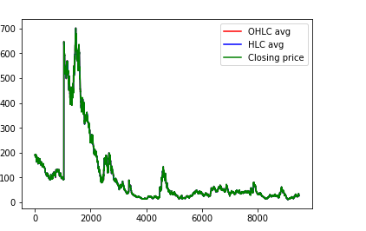
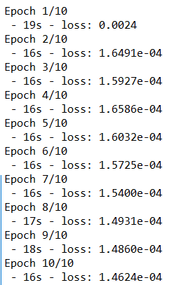
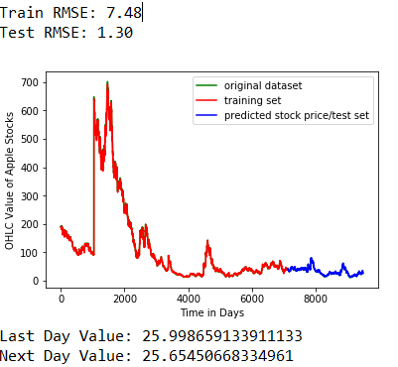

CONCLUSION-
By doing data pre-processing we can convert raw data into clean, understandable data and standardized data. Splitting the dataset into Training and testing sets. Scaling the features. It will help for share Holders to predict the future.
We can conclude that using this proposed method and algorithm we can easily and accurately predict the future price of the market.

References:-
[1] https://scikit-learn.org/stable/modules/generated/sklearn.preprocessing.MinMaxScaler.html

[2] https://scikit-learn.org/stable/index.html

[3] Wikipedia

